Things to Remember

Some simple things to do to help you when you take any test:


1. Get a good night's sleep.

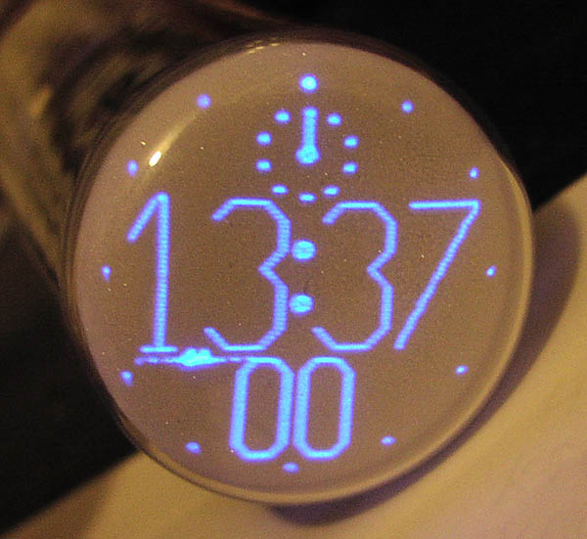

- Arrive to school on time.

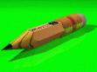

3. Have sharpened pencils with good erasers.

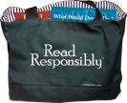
4. If your teacher allows it, bring a book to read or something to work on if you finish early.

